

**公司简介**

决策者集团（股票代码: 837621）是**国内首家**专注于产业研究和产业论坛的新三板上市公司于2004年在上海成立。

目前，决策者集团是**国内规模和影响力最大**的产业研究和产业会议公司。公司自成立以来已成功举办了近500场大型国际产业会议，总参会高层人群近**30万人次**。

通过在产业研究和产业国际会议领域的十几年深耕，集团已在沉淀中转型和升级了新业务，除了可以策划一个个具备国际影响力的产业会议，决策者集团还立足于推广企业对event marketing（活动营销）的认知：我们坚信通过events（各类定制活动）进行企业的marketing（市场营销）其效果远高于目前的普遍认识，无论对B2B企业还是B2C企业，我们都致力于帮助客户通过一次次实践来加强认识。

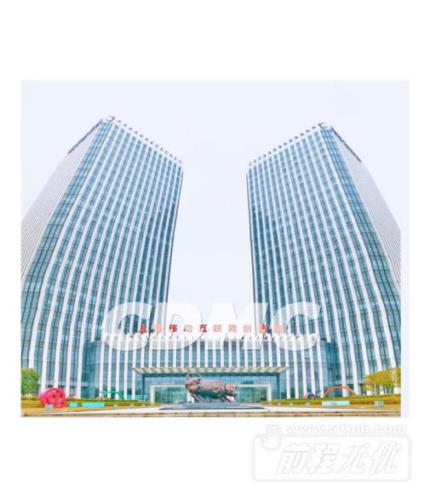

Founded in 2004, CDMC GROUP (837621. OC) now has become Asia's top global industry conference organizer over the past 14 years.  
 With a group of more than **100 multinational talents**, CDMC has

created **7 industry clusters** and organized more than **500 industry**

**conferences** with nearly3hundred thousand C-level delegates. As China's

economy evolves, so does CDMC.

In May, 2016, CDMC Group listed on the China New Third Board, namely

the national SME share transfer system (Stock Code: 837621),

which means its more responsibilities, not just using events marketing (tailor-made events) to help raise brand awareness and attract more customers, but also in leading the sector's innovation and breakthrough.

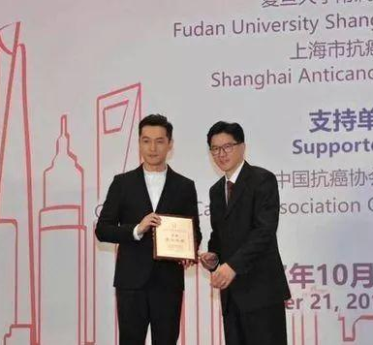

Wechat：even34

evenzh@cdmc.org.cn

上海市宝山区逸仙路2816号华滋奔腾大厦1301室



Wechat：even34

上海市宝山区逸仙路2816号华滋奔腾大厦1301室

evenzh@cdmc.org.cn

这里你可以得到全面的发展  
这里你可以接受标准的口语培训  
这里你可以摆脱哑巴英语  
这里你有更多和外资高管交流的机会  
这里你可以得到更多的出国机会  
这里你可以晋升为管理层次的机会

学习:工作中可以深入了解到各行业知识

人脉：对接客户都是500强企业高管，帮你开拓高端人脉，为以后发展做铺垫；  
出国:优秀的员工将有机会亲临海外会议现场，学习500强的企业管理及思维模式 ；

**【成长发展】**

**【企业优势】**





薪资：底薪(每年调薪) +各类单项奖金（月/季/年）+高额提成（5%-20%）高于同行+入职当月缴纳五险一金+饭贴+车贴（每月补贴1-2K）+工龄工资（月薪轻松过万）  
福利：商业保险、年终奖、带薪年假（5-20天）、旅游(海外）、团建、饭贴、车贴、生日party等

发展：开放式的晋升渠道（公开），无上限的晋升空间（透明）

培训：完善的培训课程及一对一师徒帮带制。统一进行带薪岗前培训，不定期组织职业或技能培训（礼仪/产品知识/销售技巧/商务英语 等等 ），可以提升自身的素养及语言能力

**【薪资福利】**

**【薪资福利】**



Wechat：even34

上海市宝山区逸仙路2816号华滋奔腾大厦1301室

evenzh@cdmc.org.cn

**岗位介绍**

**Job Description**

国际&国内峰会 销售管培生

『Sales Management Trainee』

**目标客户：**全球500强企业的决策人（高管）

**成长机会：**初级销售->资深销售->项目主管->项目经理

**薪资福利：**有竞争力工资+绩效奖金+丰厚业绩提成（高于同行提成4倍）+五险一金（入职缴纳）+补充年假+补贴

**岗位职责：**

1.通过网络等各种渠道进行市场调研，寻找潜在目标客户

2.通过电话、邮件、联系潜在客户，邀请参与高端会议

**任职资格：**

1. 海外峰会销售，英语6级，且口语流利。
2. 国内峰会销售，普通话标准，口齿清晰。

**实习薪资：**3000-5000元/月+提成3%-20%（毕业后可转正式编制）**预计收入：**6万/年

**转正薪资：**4500-6000元/月+饭贴+提成5%~20% **预计收入：**10-15万/年



Wechat：even34

上海市宝山区逸仙路2816号华滋奔腾大厦1301室

evenzh@cdmc.org.cn

市场专员

『Marketing Executive』

**Our Marketers**are creative yet analytical, strategic yet innovative. Passionate about content creation and community build. Our Marketing Executive are expert negotiators with both an eye for detail and a helicopter view. A Marketing Executive is responsible for implementing the overall marketing strategy to achieve the core event objectives - meeting visitor registration and attendance goals, meeting conference delegate revenue numbers, building brand awareness, and driving qualified sales exhibitor leads to achieve sales revenue goals.

**Responsibilities：**

1. Conducting detailed response analysis and formulating targeted marketing strategies;
2. Forging long-term marketing partnerships with media partners.
3. Invitation, confirmation and management of ongoing relations with speakers;
4. Delivering the SEO, email marketing, managing and maintaining the organization’s websites and display marketing channel plans;
5. Querying databases and generating list build strategies;
6. Working with Conference Producer to further develop a social media strategy that supports overall brand goals;
7. Working closely with other internal departments to achieve project objectives;



Wechat：even34

上海市宝山区逸仙路2816号华滋奔腾大厦1301室

evenzh@cdmc.org.cn

**Requirements:**

1. Students who will graduate in 2020 ;
2. Fluent written and spoken English skill, CET6 is required;
3. Exceptional interpersonal skills and a true team-player;
4. Outstanding organizational, prioritization and multitasking skills;
5. Detail focused and analytically inclined;
6. Ability to work independently under tight deadlines;
7. Self-driven, results-oriented, with a positive outlook.

**Internship Salary：：** 3,000 yuan/month+ Bonus（Be able to become a regular member）

**[Anticipated revenue](http://www.baidu.com/link?url=JfHWuLBrsNC7YXKMiozbcPuav_cQV21a1DXtaFDqXn7uby4AGbXNrBjm3gidhJHMVxsVxbgBZyQoLvFBEP82x9F1QIU979GYNgE_T8uHshUklepvL7w7oz50KYtek9Lu&wd=&eqid=c7d579270070fb5e000000045d5f5bbc" \t "https://www.baidu.com/_blank)：** 50,000 yuan/year

**Salary After Probation:** 4,500-6,000 yuan/month+ Lunch Allowance + Bonus

**[Anticipated revenue](http://www.baidu.com/link?url=JfHWuLBrsNC7YXKMiozbcPuav_cQV21a1DXtaFDqXn7uby4AGbXNrBjm3gidhJHMVxsVxbgBZyQoLvFBEP82x9F1QIU979GYNgE_T8uHshUklepvL7w7oz50KYtek9Lu&wd=&eqid=c7d579270070fb5e000000045d5f5bbc" \t "https://www.baidu.com/_blank)：** 10,000-12,000 yuan/year



Wechat：even34

上海市宝山区逸仙路2816号华滋奔腾大厦1301室

会议策划

『Conference Producer』

**Responsibilities：**

1. Intensive primary research to ascertain and validate conference content with senior executives, plus some secondary publication and web research；
2. Development of in-depth sales, marketing and project briefs summarizing the main findings of your research for the wider project team；
3. Invitation, confirmation and management of ongoing relations with senior speakers;
4. Creation of original, engaging sales copy for the event brochure, website and associated promotional pieces.
5. Work closely with marketing and sales teams to develop and aid in the execution of comprehensive cross-functional strategies;
6. Work as a meeting sales for some time to understand our target customers' requirements better.

evenzh@cdmc.org.cn



**Requirements：**

1. A bachelor’s degree is required; a master’s is preferred.
2. Curious, commercial & smart. Dynamic communicators and persuasive influencers;
3. An overachiever, competitive, self-driven, self-motivated, goal oriented and confident. You not only hit your goals, but exceed them;
4. Fluent written and spoken English skill, CET6 is required.
5. Passionate about doing work that excites and inspires others;
6. Unstoppable and poised under pressure; you thrive under deadlines and can manage multiple projects simultaneously;
7. Self-assured and confident speaking with senior level executives;

**Internship Salary：** 3000 yuan/month+ Bonus（Be able to become a regular member）

**[Anticipated revenue](http://www.baidu.com/link?url=JfHWuLBrsNC7YXKMiozbcPuav_cQV21a1DXtaFDqXn7uby4AGbXNrBjm3gidhJHMVxsVxbgBZyQoLvFBEP82x9F1QIU979GYNgE_T8uHshUklepvL7w7oz50KYtek9Lu&wd=&eqid=c7d579270070fb5e000000045d5f5bbc" \t "https://www.baidu.com/_blank)：** 50,000 yuan/year

**Salary After Probation:** 6,000-8,000 yuan/month+ Lunch Allowance + Bonus

**[Anticipated revenue](http://www.baidu.com/link?url=JfHWuLBrsNC7YXKMiozbcPuav_cQV21a1DXtaFDqXn7uby4AGbXNrBjm3gidhJHMVxsVxbgBZyQoLvFBEP82x9F1QIU979GYNgE_T8uHshUklepvL7w7oz50KYtek9Lu&wd=&eqid=c7d579270070fb5e000000045d5f5bbc" \t "https://www.baidu.com/_blank)：** 120,000-150,000 yuan/year

Wechat：even34

上海市宝山区逸仙路2816号华滋奔腾大厦1301室

evenzh@cdmc.org.cn



**招聘流程**

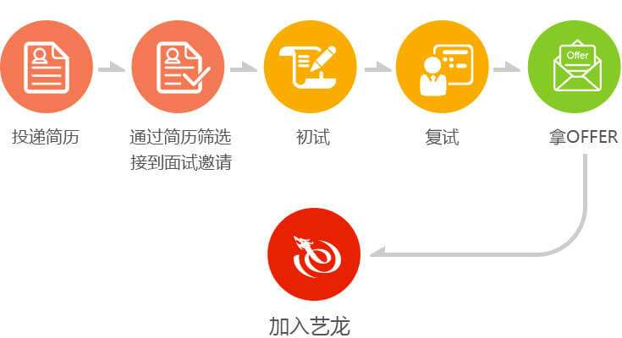

**书面测试**

**电话面试**



**加入CDMC**

evenzh@cdmc.org.cn

上海市宝山区逸仙路2816号华滋奔腾大厦1301室

Wechat：even34



* 人事微信  CDMC-HR
* 电子邮箱  [evenzh@cdmc.org.cn](mailto:evenzh@cdmc.org.cn)
* 公司电话：68407631*8089/*8125
* 公司官网   [www.cdmc.org.cn](http://www.cdmc.org.cn)
* 工作地址   上海市逸仙路2816奔腾大厦号华滋B幢1301室 (地铁3号线长江南路站1号口左转步行5分钟)

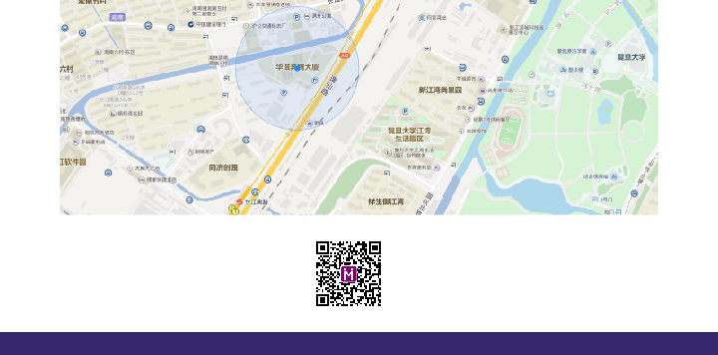

**联系方式**

**Contact Us**

evenzh@cdmc.org.cn

Wechat：even34

上海市宝山区逸仙路2816号华滋奔腾大厦1301室

上海市宝山区逸仙路2816号华滋奔腾大厦1301室

Wechat：even34

evenzh@cdmc.org.cn